



**Placement Empowerment Program**

***Cloud Computing and DevOps Centre***

Task:Set up a Virtual Machine in the Cloud

Name: Gobika S Department: CSE



# Introduction

Introduction to Setting Up a Virtual Machine in the Cloud

A **Virtual Machine (VM)** in the cloud is a computing resource that runs on a cloud provider's infrastructure. It allows users to deploy applications, test environments, or run workloads without needing physical hardware.

This **Proof of Concept (PoC)** aims to guide you through the process of setting up a virtual machine on major cloud platforms like **Amazon Web Services (AWS), Microsoft Azure, or Google Cloud Platform (GCP)** using their **free-tier** offerings. The steps include:

1. **Creating a Cloud Account** – Sign up for a free-tier account on AWS, Azure, or GCP.
2. **Launching a Virtual Machine** – Choose an appropriate VM configuration and operating system.
3. **Connecting via SSH** – Securely access the VM using SSH from your local machine.

By the end of this PoC, you will have a running cloud-based VM that you can use for development, testing, or hosting applications.

# Overview

**Step-by-Step Overview for Setting Up a Virtual Machine in the Cloud (PoC)**

**1: Create a Cloud Account**

**Sign up for a free-tier accounton one of the major cloud providers:**

**AWS (Amazon Web Services) –** [**AWS Free Tier**](https://aws.amazon.com/free/)

**Azure (Microsoft Azure) –** [**Azure Free Account**](https://azure.microsoft.com/en-us/free/)

**GCP (Google Cloud Platform) –** [**Google Cloud Free Tier**](https://cloud.google.com/free)

**Verify your email, phone number, and payment method (most providers require a credit card for verification but won’t charge for free-tier usage).**

**2: Access the Cloud Console**

**Log in to the respective cloud console:**

**AWS Console:** [**AWS Management Console**](https://aws.amazon.com/console/)

**Azure Portal:** [**Azure Portal**](https://portal.azure.com/)

**Google Cloud Console:** [**Google Cloud Console**](https://console.cloud.google.com/)

**3: Launch a Virtual Machine (VM)**

**Navigate to the Compute Servicessection:**

**AWS: EC2 (Elastic Compute Cloud)**

**Azure: Virtual Machines**

**GCP: Compute Engine**

**Click on Create Instance / Launch VM Configure the following settings:**

**Choose OS (Ubuntu, Windows, CentOS, etc.)**

**Select Machine Type (Free-tier eligible instance like AWS t2.micro, Azure B1s, or**

**GCP e2-micro)**

**Configure Network & Security (Ensure SSH is enabled)**

**Create & Download SSH Key Pair (AWS & GCP) or set up username/password**

**(Azure)**

**Launch / Deploy the VM**

**4: Connect to the VM via SSH**

**Once the VM is running, retrieve its public IP address Open a terminal (Linux/macOS) or use PuTTY (Windows) Connect using SSH: ssh -i your-key.pem username@public-ip**

**AWS: ssh -i key.pem ec2-user@public-ip**

**Azure: ssh username@public-ip**

**GCP: ssh username@public-ip (or use Google Cloud Console SSH button)**

**5: Verify and Use Your VM**

**Run basic commands to ensure the VM is working: uname -a # Check system info df -h # Check disk usage top # Monitor processes**

**Install required packages or deploy an application as needed**

**Step-by-Step Overview**

Step 1:

Navigate to the aws console and search ec2

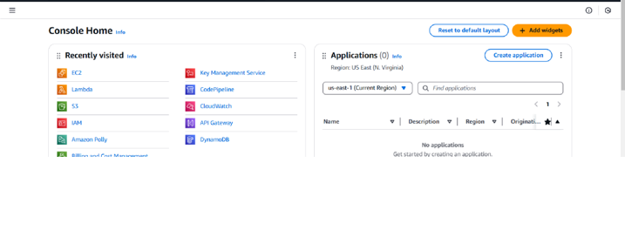

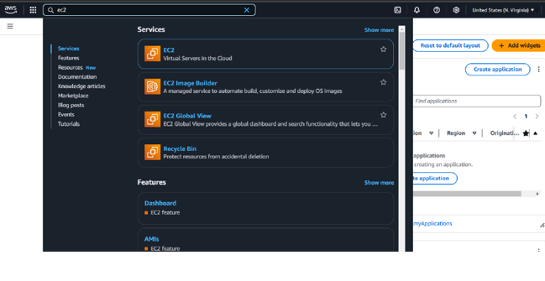

Step 2

Now click the ec2 and launch an instance

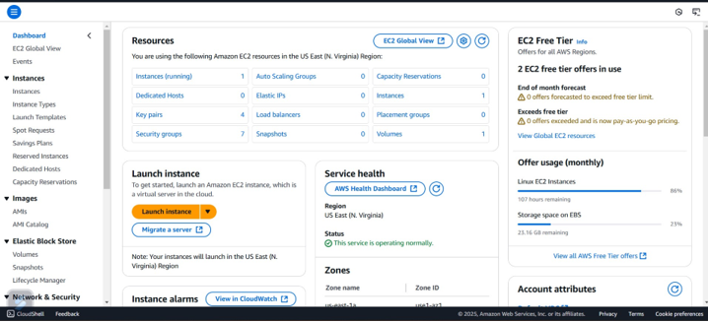

Step 3:

Name the instance and create an new key pair name

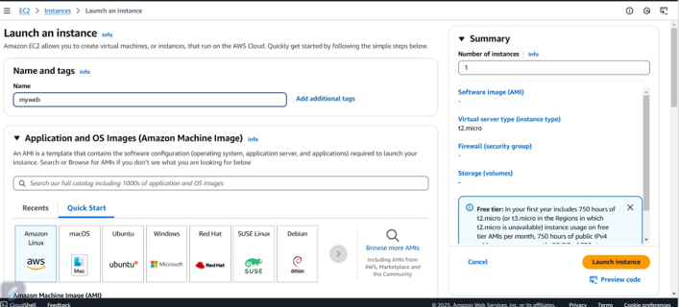

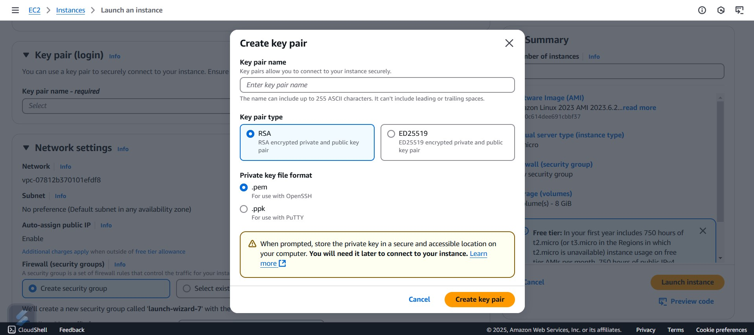

Step 4:

Click to launch instance button and your instance has been launched

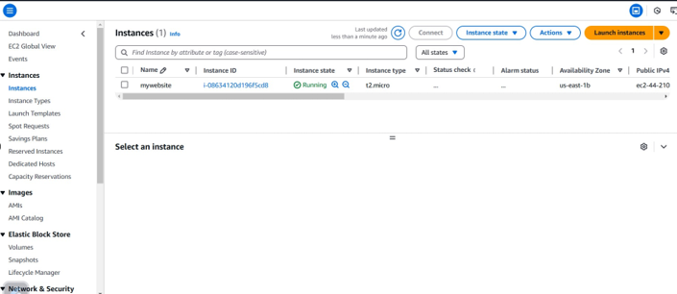

# Expected Outcome

After completing these steps, you will have a **fully functional cloud-based virtual machine** that can be accessed remotely. This VM can be used for **development, hosting applications, or running workloads**.